NPT 25SETC-xxxx

Type the Title of your Paper Here

Author, co-author list

Affiliation

ABSTRACT

Replace this description with text. The manuscript elements have been formatted to the SAE Technical Paper Style Guide (<http://volunteers.sae.org/authors/styleguide.pdf>). This chapter is to be published in the final program of the conference. Maximum number of the words in the program will be 250. Therefore, please try to limit this chapter up to 250 words. Otherwise, the last part may not be shown in the program. Don't reduce ABSTRACT in order to fit the specified number of pages.

body(METHOD AND RESULT)

It is recommended that the body of the paper include methodology, assumptions, hardware, observations, analysis and a comparison of results with prior work. If the volume is expected to exceed the limit, however, it is acceptable to describe essential parts only. Define all terms at first usage and apply them consistently.

The body section is not entitled Body. The title should be changed according to your descriptions. Common examples include Methods, Result, Discussion. Figures, tables, and equations fall under the body section. Found in this template are examples of a figure, a table, and equations.

Table 1 is an example of a table and table title. Table titles are Times New Roman, 10 point. The [Normal] style tag should be applied to the table text. Style tag can be applied by feature of MS WORD.

Table 1. Example of a table.

|  |  |
| --- | --- |
| Displaced volume | 1966 cm3 |
| Stroke | 154 mm |
| Bore | 127.5 mm |
| Number of valves | 2 |

Figure 1. Example of a figure and figure caption. The axes should be identified and should be legible if printed on an 8.5”x11” or A4 size paper.

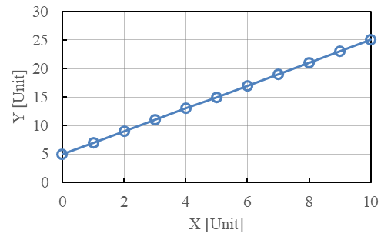

Figure 2. Example of a figure and figure caption.

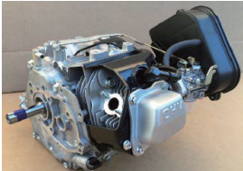

Captions for figures are Times New Roman, 10 point.

This is an example of an ordered list. When creating this type of list, enclose number or letter in parenthesis i.e. (1) or (a) as number as shown in this example.

Shown are examples of equations. All equations wider than one line must be wrapped to the next line as shown in these equations.

$$\frac{dλ}{dt}=\left[\frac{\sqrt{1+16{1\left(\frac{x}{x^{+}}\right)}^{2}}-12}{2{\left(A/F\right)}_{st}}-\frac{\sqrt{1+16{1\left(\frac{x_{prev}}{x^{+}}\right)}^{2}}-1}{2{\left(A/F\right)}_{st}}\right]$$

$\left(1-BGF_{st}\right)∙ \frac{12}{\left(t-t_{prev}\right)}$

(1)



(2)

Summary/Conclusions

Summarize your conclusions briefly. Everything must be included on two pages, though one page is recommended.